ASSIGNMENT-4.4
R.Abhinav Reddy
2303A52348
Batch: 44

1. Sentiment Classification for Customer Reviews
Scenario:
An e-commerce platform wants to analyze customer reviews and classify them into Positive, Negative, or Neutral sentiments using prompt engineering.
Tasks:
Prepare 6 short customer reviews mapped to sentiment labels.
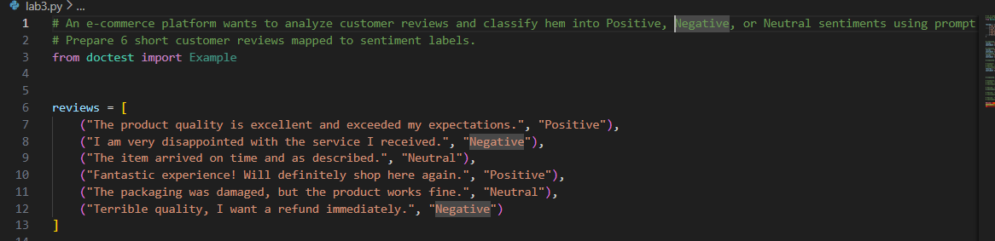
*Design a Zero-shot prompt to classify sentiment.
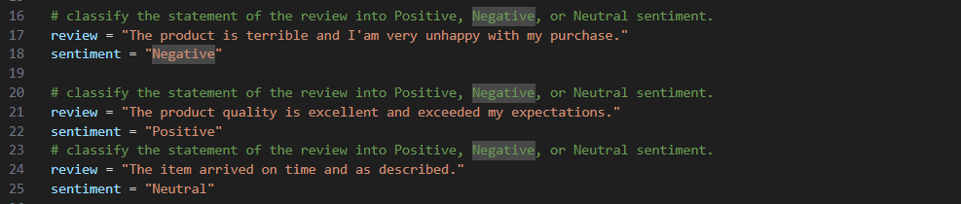
*Design a One-shot prompt with one labeled example.
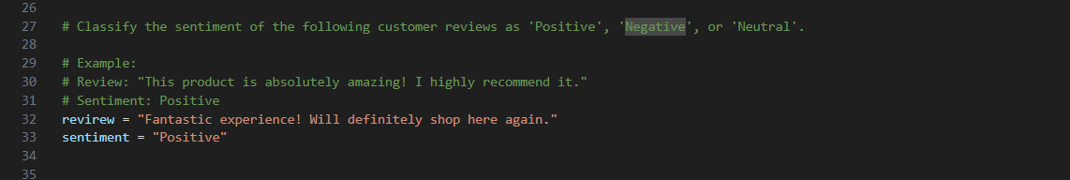
*Design a Few-shot prompt with 3–5 labeled examples.
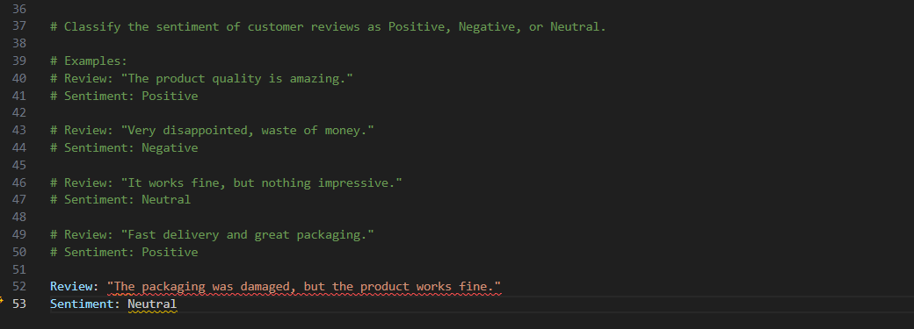
*Compare the outputs and discuss accuracy differences:
Few-shot prompting gives the highest accuracy because multiple labeled examples help the model learn patterns clearly. One-shot prompting improves accuracy compared to zero-shot by giving guidance through a single example. Zero-shot prompting is useful but less reliable, especially for neutral or mixed-sentiment reviews.

2. Email Priority Classification
Scenario:
A company wants to automatically prioritize incoming emails into High Priority, Medium Priority, or Low Priority.
Tasks:
*Create 6 sample email messages with priority labels.
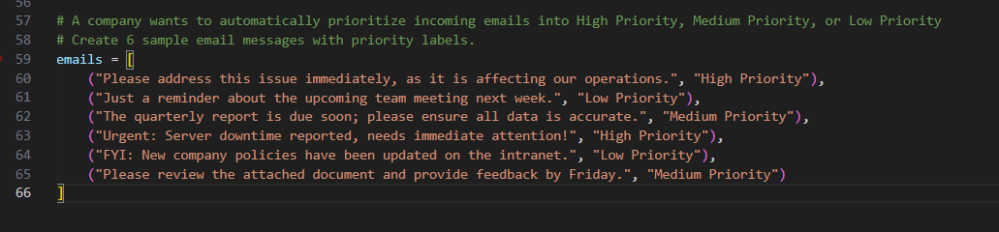
*Perform intent classification using Zero-shot prompting.
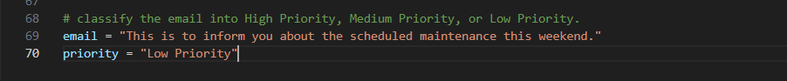
*Perform classification using One-shot prompting.
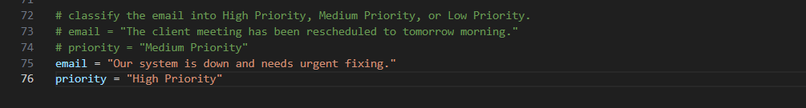
*Perform classification using Few-shot prompting.
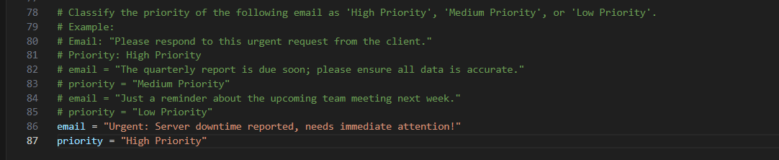
*Evaluate which technique produces the most reliable results and why. ?
Few-shot prompting is likely to yield the most reliable results due to the presence of multiple abelled examples that help the model understand the context and nuances of email prioritization. One-shot prompting can also improve accuracy by providing a single example, but it may not capture the full range of scenarios as effectively as few-shot prompting. Zero-shot prompting, while useful, may struggle with accurately classifying emails without any prior examples, especially when distinguishing between Medium and Low Priority emails.

3. Student Query Routing System
Scenario:
A university chatbot must route student queries to Admissions, Exams, Academics, or Placements
Tasks:
*Create 6 sample student queries mapped to departments.
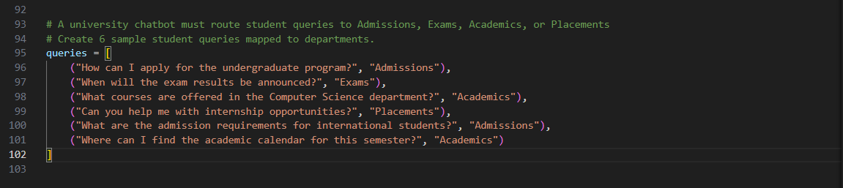
*Implement Zero-shot intent classification using an LLM.
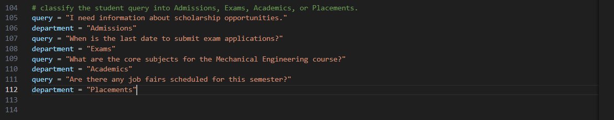
*Improve results using One-shot prompting.
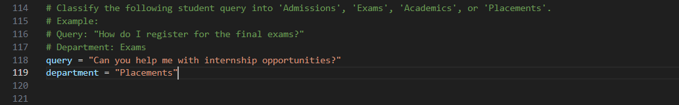
*Further refine results using Few-shot prompting.
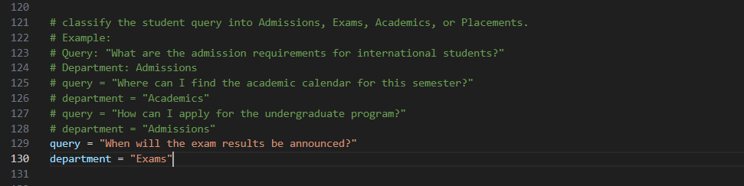
*Analyze how contextual examples affect classification accuracy.:
Few-shot prompting is expected to provide the highest classification accuracy due to the presence of multiple labeled examples that help the model understand the context and nuances of student queries. One-shot prompting can also enhance accuracy by providing a single example, but it may not cover the full spectrum of possible queries as effectively as few-shot prompting. Zero-shot prompting, while useful, may face challenges in accurately classifying queries without any prior examples, especially when distinguishing between similar departments like Academics and Admissions.

4. Chatbot Question Type Detection
Scenario:
A chatbot must identify whether a user query is Informational, Transactional, Complaint, or Feedback
Tasks:
*Prepare 6 chatbot queries mapped to question types.
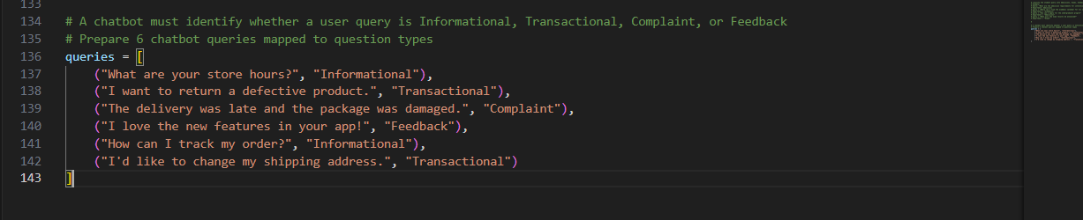
*Design prompts for Zero-shot, One-shot, and Few-shot learning

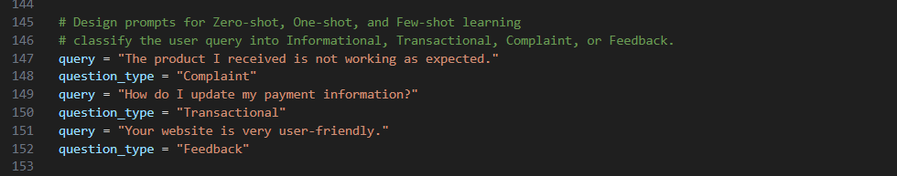
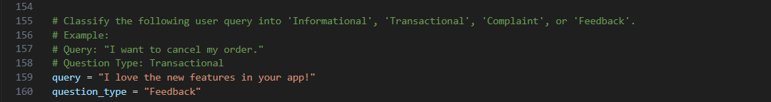
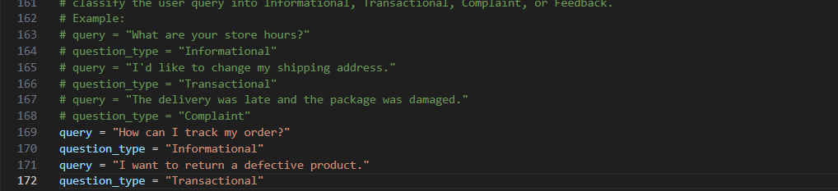
*Test all prompts on the same unseen queries:
Few-shot prompting is expected to yield the most reliable results due to multiple labeled examples that help the model understand different query types. One-shot prompting can improve accuracy by providing a single example, but may not cover all scenarios as effectively. Zero-shot prompting may struggle with accurately classifying queries without prior examples, especially when distinguishing between similar types like Informational and Feedback.

* Compare response correctness and ambiguity handling :
Few-shot prompting is likely to produce the most accurate and reliable classifications due to the presence of multiple examples that illustrate the distinctions between query types. This helps the model learn patterns and nuances more effectively. One-shot prompting can also enhance accuracy by providing a single example, but it may not capture the full range of scenarios as comprehensively as few-shot prompting. Zero-shot prompting, while useful for quick classifications, may struggle with ambiguity and subtle differences between query types, leading to less reliable results. Overall, few-shot prompting is expected to outperform the other techniques in terms of correctness and handling ambiguous queries.
* Document observations :
Few-shot prompting is expected to provide the most accurate classifications due to the presence of multiple examples that illustrate the different query types. One-shot prompting can also enhance accuracy by providing a single example, but it may not cover the full spectrum of query types as effectively as few-shot prompting. Zero-shot prompting, while useful for quick classifications, may struggle with accurately identifying the nuances between similar query types without any prior examples.

5. Emotion Detection in Text
Scenario:
A mental-health chatbot needs to detect emotions: Happy, Sad, Angry, Anxious, Neutral
Tasks:
*Create labeled emotion samples.
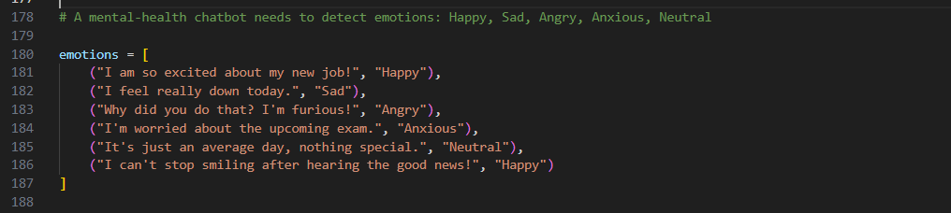
*Use Zero-shot prompting to identify emotions.
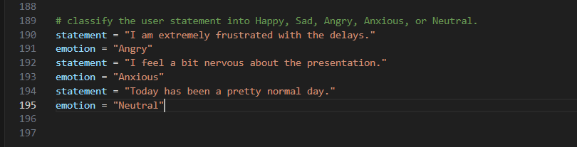
*Use One-shot prompting with an example
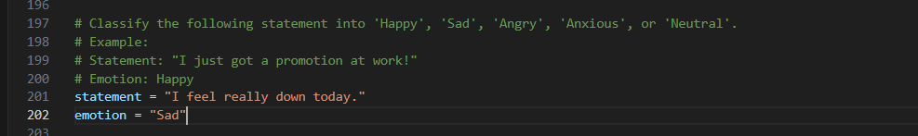
*Use Few-shot prompting with multiple emotions.
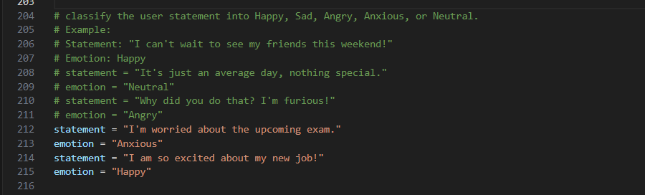
*Discuss ambiguity handling across techniques :
Few-shot prompting is expected to handle ambiguity better due to the presence of multiple examples that illustrate different emotional contexts. This helps the model learn subtle differences between similar emotions, such as Sad and Anxious. One-shot prompting provides some guidance but may not cover all nuances, leading to potential misclassifications in ambiguous cases. Zero-shot prompting relies solely on the model's pre-existing knowledge, which may not be sufficient for accurately distinguishing between closely related emotions, especially in complex or nuanced statements.

